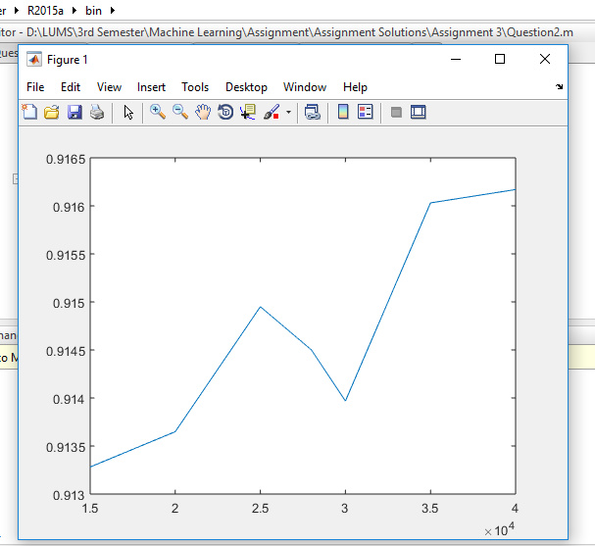

When we increase the data then our model works better but after increasing more and more the model becomes complex and more expressive and consequently over fitting arises.